Family Partnerships of Central Florida

A Community-Based Care Agency

Board Report
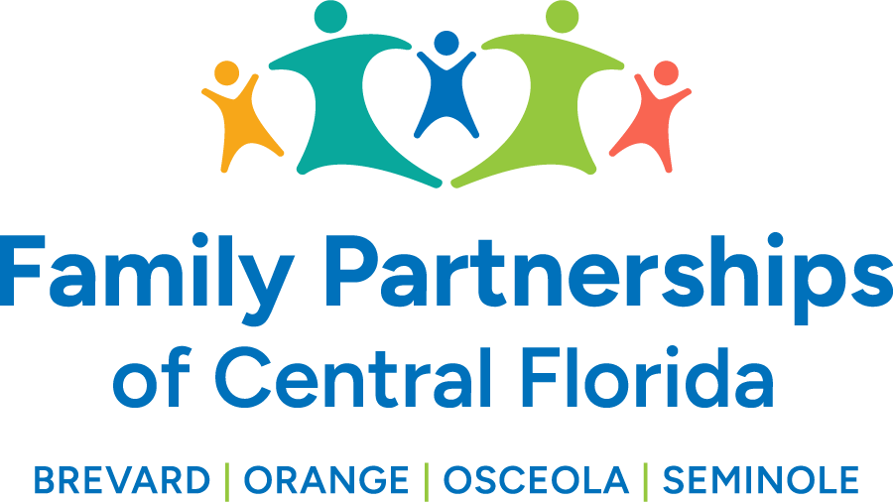


February 27, 2025

Phil Scarpelli, Chief Executive Officer

Summary

- FCC Updates – Attended an aggressive week in Tallahassee having one-on-one with our delegation discussing many issues relative to our funding model and the costs throughout our transition. I wrapped up providing each of them with the numerous accomplishments by FPOCF since the inception of our expanded contract. They were each very impressed and extended much appreciation to our workforce.
- IT Selection Updates – After going through a competitive procurement of our MIS/IT to services, we have awarded the contract to iTech for their innovative and comprehensive proposal that will work in concert with our in-house MIS team for a very competitive price point.
- Rally in Tally Updates – I worked in concert with the membership of the Florida Coalition for Children on our strategic initiatives to engage and educate the issues challenging our industry this year to include Bills that may impact Limited Liability Insurance of Lead Agencies in both Capitation and rising cost of premiums, KPMG’s Funding Model, retroactive pay to our foster families,
- Foster Parent Celebrations – This past weekend I had the privilege to attend the Foster Parent Appreciation breakfast. I was to sit and break bread with our families to celebrate their commitment to our children in care and spoke to the entire group about my customer service expectations of our workforce. I asked them to join my movement on getting case workers and foster families/caregivers to build relationships that work harmoniously to serve our children together. I reminded them that the relationship between our foster families and case workers are the most impactful experiences within our system of care.
- I shared my vision and expectations with my direct reports which focused on a united effort to evaluate and develop their direct reports, relative to an expectation on challenging them to their next level of performance. I have asked them to join me in making 2025 a year focused also on driving a very intentional internal customer service initiative, since “internal customer service will drive external customer service.” Both to these focal points will be an ongoing topic of discussion and evaluation which I believe will further build upon retention and workforce satisfaction.
- I have been continuing my efforts on uniting our four counties’ ability to engage their respective children alliance in an effort to exchange best practices, re-evaluate the alliance’s purpose, initiatives, goals and expansion. The chairs from each county have truly enjoyed and appreciated building these relationships and have further agreed on quarterly gatherings throughout the year.

Updates

- Just a reminder to existing Board members that if you happen to know individuals who may be an ideal fit to join our Governance Board, please reach out to me to make a warm hand-off or to join me in engaging such individuals in the prospect of joining our efforts in leading this organization’s mission, now in four counties.

Respectfully Submitted,

Phil Scarpelli
Chief Executive Officer

