Board Report
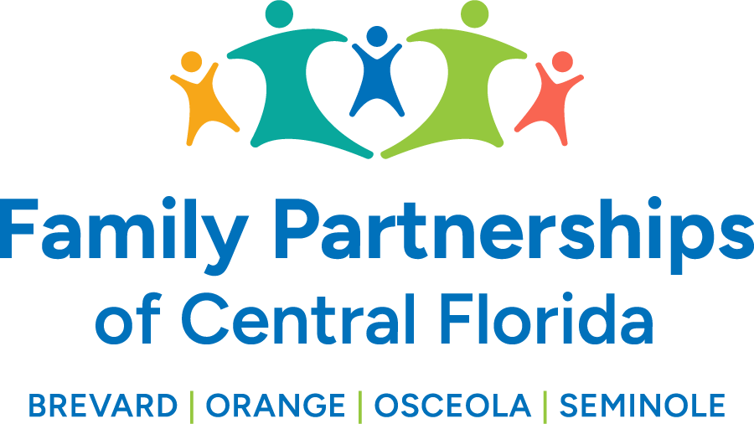


)

October 24, 2024
Phil Scarpelli, President and Chief Executive Officer

Summary

- Budget Updates – We have completed our budget exercise with an acceptable balance for the upcoming fiscal year. We will closely monitor our expenses conservatively and subsequently only fill mission critical positions throughout the year. We are working closely with the Department, FCC and KPMG as we continue the data gathering and analyses which we optimistically anticipate a favorable response from the legislators. Our focus is to deliver an actuarial model that will finally reflect a more accurate cost of doing child welfare services in Florida.

- State Updates – Several of our team members attended this year’s DCF Summit in Orlando. It was the largest statewide attendance to date with the Governor and First Lady present and engaged in a dialogue with our Secretary Harris. I was privileged to be invited on stage to speak on my perspective on the significance of engaging fathers in the dependency system, comparative to the historical absence of fatherhood engagement in our state. I was also asked to speak to the Youth Leadership Academy Graduates and the membership of the statewide Youth Sunshine association about how to take their leadership education to the next level of application.

- Vulnerable Children’s Initiative/Rosen Shingle Creek – I was excited to accept another invitation this past month to be an honored guest at this year’s VCI Conference. I was interviewed with regard to our organization’s involvement and partnership with the faith-based community. I engaged 50 men who were newly trained in the TBRI (Trust Based Relational Intervention) to discuss and recognize their commitment and investment in a model that enhances the role of the father in the life of children with adverse childhood experiences. I was humbled to speak to this father’s group about the impact of taking their training into the home and building stronger relationships while helping children heal.

- Tri-county Foster Parent Association – Last month I participated in their monthly support group as a guest invited by their association president. In addition to it being an introductory meeting, it was an opportunity to gather their priorities and “asks” of the Lead Agency. The primary issues were childcare and working with the local Early Learning Coalitions, communication and points of contact with FPOCF, relationships with caseworkers and a desire to understand FPOCF priorities.

- Kids House of Seminole County – I attended their annual event celebrating the year in reflection and the signing of their partnership agencies’ memorandum of understanding (MOU). Seminole is a very close-knit community and very prideful for how they leverage their resources. The Seminole County Sheriff’s Department as a central figure leading a number of collaborations that serve vulnerable children and their families. I have been invited to become one of their Board Members.

- We have re-established our combined Car 4Kids/Road to Autonomy programs re-evaluating criteria, protocol and business affiliates, Banks and Car “broker.” We are excited about increasing the number of eligible youths to earn a vehicle in order to assist with transportation for employment and educational opportunities. If you know of anyone in the community who wishes to donate a used car, please have them reach out to us!

- I will continue to provide Storm readiness Activities and soon post Milton response. We have a wonderful 22 man/woman team working daily on storm readiness assessments, exercising our communication plan, facility preparedness, and ongoing check-ins accounting for all children in care, all of our caregivers and partner agencies. We began facility closure effective 5:00 pm 10/8 with staff working virtually from home. Our Emergency Response System members will continue to connect daily and make determination as facility closures, staff accountability, children and families’ safety and wellness, and connectivity with our partner agencies.

Updates
- Just a reminder to existing Board members that if you happen to know individuals who may be an ideal fit to join our Governance Board, please reach out to me to make a warm hand-off or to join me in engaging such individuals in the prospect of joining our efforts in leading this organization’s mission, now in four counties.

Respectfully Submitted,
Phil Scarpelli, President and Chief Executive Officer

