Brevard Family Partnership

A Community Based Care Agency

Board Report
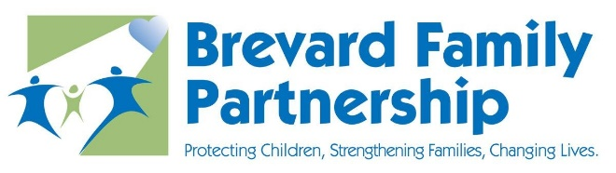

September 22, 2022

Phil Scarpelli, President and Chief Executive Officer

- We are delighted to announce that Rebecca Melick (current Interim Executive Director of Brevard CARES) has accepted the position as the new Executive Director of Brevard CARES. Her wealth of experience with the CARES program, dedication, leadership integrity and supportive commitment to this position in the past makes her an invaluable individual to fill these shoes. Rebecca not only has the experience from a leadership standpoint, but she also has the lived experience on the opposite side of the table as a foster parent. We are eager to see her soar in this new role!

- I participated in the Florida Coalition for Children’s annual retreat with all the community-based care organization CEOs across Florida for a strategic planning day earlier this month. The goals established by consensus under the guidance of a consultant are as follows: 1) establish our “brand” as subject matter experts in Florida’s Child Welfare System in order to influence our funder and contract holder in developing and maintaining best practices for our children and families; 2) to establish organizational excellence across the CBC continuums of care; 3) to advocate on behalf of all community-based care and partner agencies to our states legislative and executive branches of government; 4) and last but not least, to continue strengthening our relationship with the Department of Children and Families.

- Numerous members from all our agencies, including leadership and front-line staff members were granted the opportunity to attend the DCF Summit conference earlier this month in Orlando. Our team also collaborated with several other organizations for a break-out session/workshop and the impact that our speakers had upon the audience was phenomenal!

- We are exploring a partnership opportunity with Costa Surf to provide our foster children with needed mentors and even the opportunity to learn water safety, receive mentors while learning to surf in a therapeutic experience! A variety of logistics must align for us to proceed in this process, and we are working through our next steps. We cannot wait to share further information with you soon!

- Insperity recently conducted an FOA-wide survey to gauge how our workforce’s work experience was rated in a variety of domains. Findings and analyses will directly influence our organization’s internal strategic plan. Our goal is to hire the best in the industry, with a priority of making their career with us productive and fulfilling and so that they provide the best services for our county’s most vulnerable children and their families.

- Upcoming Community Events:

- The BFP Golf Tournament fundraiser is fast approaching this Saturday, September 24th. Thank you, Carlos and Community Credit Union for your golfer additions and sponsorship!

- Our Over the Edge event is taking place during the day on New Year’s Eve, December 31st. This unique fundraiser has the potential to significantly impact our Foundation’s financial goals. We need your help to promote!

- We have the Hilton Melbourne booked in March of 2023 for another fundraising event opportunity – more information to come!

Respectfully,
Phil Scarpelli, President and CEO

