Brevard Family Partnership

A Community Based Care Agency

Board Report
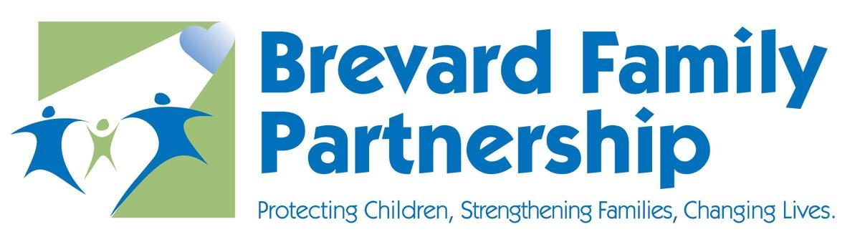

October 17, 2019
Dr. Valerie Holmes PhD
Executive Director

Key accomplishment(s) this past month (brief data to support if necessary)

Dependency Judge Jennifer Taylor provided the first foster parent support training on Thursday, October 17th at the Viera Courthouse, 35 foster families (64 foster parents) attended the training. Volunteers at Suntree United Methodist Church provided childcare for the meeting. Training was provided on the following topics:

- Foster Parent Roles in various court proceedings: Arraignment, Advisory Hearing, Status Hearings, Judicial Reviews, Dependency or Termination of Parental Rights trial, Manifest Best Interest Hearings;
- What to expect at trial – order of events;
- Testimony tips from the bench;
- Courtroom etiquette and proper attire;
- Courtroom security issues, and
- Volunteers for a mock trial.

A provider Fair held on September 30 at the Bill Posey Conference Center was a huge success! The event was well attended with 40 providers and 106 attendees. The purpose of the interface was to continue to promote positive provider relationship with the case management agency staff.

Key challenges moving forward (brief data to support if necessary)

BFP is not meeting performance targets on Contract Measures M1, M2, M3, M7, and M10 . A Work Plan has been created for each measure, created by the Data Analysis Work Group and the champions for each measure. The following training needs were identified and will be provided by the BFP Quality Assurance and Training Team.

- Human Trafficking
- Safety Planning
- Quality Supervisory Reviews
- Reunification Support Team

The following areas have been identified for improvement:

- Safety Plan Sufficiency
- Safety Plan Monitoring

In regards to the dental measure, a meeting was held with the Brevard Health Alliance to discuss the option of holding slots for dental appointments, similar to the 72 hour medical screening.

Upcoming Community Events / Any requests of the Board Members

Adoption Celebration-Friday November 22 at 11:00am at Brevard County Courthouse Room number

Thanksgiving Celebration-Saturday November 23 at 11:00am at Ascension Catholic Church in Melbourne

5th Annual Breakfast with Santa-Saturday December 14 from 9:00 to 11:00am at the Eau Gallie First Baptist Church of Melbourne

All Board members are invited to join in on the festivities!

Respectfully Submitted,

Dr. Valerie Holmes PhD
Executive Director

